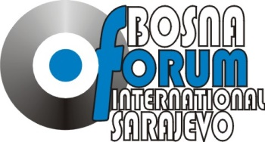

THE THIRTEENTH INTERNATIONAL CONFERENCE

UNITY AND PLURALITY IN EUROPE

(ICUPE)

From 29th to 31st July 2018

Mostar, Bosnia and Herzegovina

REGISTRATION FORM

- Name:
- Nationality:
- Gender:
- Date and Place of Birth:
- Address:
- Electronic (email):
- Telephone Number:
- Educational Background:
- Institutional Affiliation and Address:
- Language Skills:
- Participation status:
(Please emphasize your participation status)
- lecturer
- observer

Applications should be tendered to if_bosna@bih.net.ba or office@forumbosna.org by July 15th 2018 at the latest. All applicants will be informed of any decisions by the IFB Organizational Board by June 30th 2018. Participants will be selected by means of a public call. Participation fee is 200 EUR. It includes accommodation, food, materials and informal activities.

